|  | DGL 409 FALL 2023 **DIGITAL DESIGN + DEVELOPMENT** |
| --- | --- |
|

| **Course Title** |  | | |
| --- | --- | --- | --- |
| **Course Code + Delivery** | DGL 409 CVS | **Day/Time** | Monday + Thursday 8:30 - 12:30 |
| **Prerequisites** | DIGITAL Design + Development students in their final term of their program. | **Location** | Online / in-person |
| **Credits** | 3.0 credit | **Start Date** | September, 2023 |
| **Hours per week** | 4 hours | **End Date** | December, 2023 |
| **Instructor** | Megan WIlson | **NIC Email**  **NIC Phone** | megan.wilson@nic.bc.ca |
| **Office Location** | Raven 108b | **Office Hours** | Monday + Thursday 12:45 - 2:00  (online)  Tuesday 12:45 - 2:00 (R208b) |

North Island College is honoured to acknowledge the traditional territories of the combined 35 First Nations of the Nuu-chah-nulth, Kwakwaka’wakw and Coast Salish traditions, on whose traditional and unceded territories the college’s campuses are situated. The Truth and Reconciliation Commission of Canada’s final report calls for 94 actions toward restoring a balanced relationship between Indigenous peoples and settler communities in this country.

# 

# Course Description

This capstone project course provides students with the opportunity to propose and develop a self-directed body of work. The project allows students to target their area of expertise to synthesize the applied skills and theoretical knowledge of their accumulated education.

# Course Content

* Discovery, planning, production, deployment, and presentation of a capstone project
* Documenting and archiving a project’s process
* Best practices for portfolio development

# Course Learning Outcomes

**Upon successful completion of this course students will be able to:**

1. design and manage a self-directed project through the stages of discovery, planning, production, deployment and presentation;
2. research and prepare personal learning objectives for self-directed study related to the student’s preferred speciality;
3. synthesize and apply skills and knowledge acquired to date in the completion of a capstone project;
4. produce, exhibit and archive a portfolio project that includes a creative brief and process documentation;
5. organize and lead team initiatives towards final presentation of capstone projects at an annual showcase event.

# Course Format + Technology

**CVS section**

This is a face-to-face course that meets weekly at a scheduled time at the NIC Comox Valley Campus. Course specific schedules are provided by the instructor the first week of classes.

# Studio + Mac Lab Access

**Location:** Studios are located in Shadbolt Studios + Raven Hall

MAC Labs are located in Raven Hall 107 + 212

**Access Hours: Mon - Thu 8:30 am -9 pm,**

**Fri 8:30 am-4:00 pm and Sat 10 am-4 pm**

* If a class is booked in a room there is no studio/lab access during that time slot. Class schedules are posted on the doors.
* Students can drop in to use the studios/ labs. Sign-in sheet for each Studio + Lab: Students must sign in to each Studio or Lab that they use if they are not in a scheduled class during that time frame. The sign sheets are at the main door of each studio/lab.
* Photo Studios must be booked online <https://library.nic.bc.ca/Studios>

**Evening and Saturday “After Hours” Access Procedures**

For “After Hours” access **Mon - Thu 5-9pm** and **Sat 10am-4pm,** students must follow these procedures:

* Students need to call /text the monitor cell phone after 6:30pm Mon -Thurs and Sat from 10am -4pm to enter the building, be prepared to show NIC student ID.
* Studio Monitor contact via text or phone 778-585-3285 or Security (only use if required 250-334-7206)
* Sign IN sheet for each Studio + Lab: Students must sign to each Studio or Lab that they use. The sign sheets are at the main door of each studio/lab.

# Cleaning Protocols for Studios + MAC Labs

* ARRIVAL to class or work period each student is responsible for cleaning their workstations.
* Each room will be stocked with cleaning supplies.
* COMMUNAL EQUIPMENT + WORKSTATIONS each student is responsible for cleaning the equipment and space prior to use.
* DEPARTURE at the end of each class each student is to leave their workstation clean.

# Course Workload

**Students in DIGITAL Design + Development programs should expect to put 8 - 12 hours per week into each 3-credit course.** This means 40 hours per week minimum across all courses in a full course load of five courses. The 8 – 12 weekly hours per course include reviewing all course material (lectures, demonstrations, readings), and completing weekly assignments and larger projects.

# Professionalism

Students are expected to be self-motivated, organized, and punctual. Participation is essential for the success of class discussions and critiques. It is through discussion of concepts and artwork that students develop the ability to perceive and articulate ideas. Dialogue is encouraged to develop positive constructive debates and offer an interactive space where students learn from one another. Thoughtful and serious engagement, critical thinking and sensitivity regarding other students and their work are integral*.*

# Evaluation

| Assignment 1: Project brief | 10 |
| --- | --- |
| Assignment 2: Planning documents | 10 |
| Assignment 3: MVP | 15 |
| Revisions | 2.5 |
| Assignment 4: Features | 15 |
| Revisions | 2.5 |
| Assignment 5: Features + testing | 15 |
| Revisions | 2.5 |
| Assignment 6: Final project + case study | 17.5 |
| Professionalism | 10 |
| **Total** | **100 %** |

# Assignments Submission

All course work must be handed-in by the submission deadline. Late submissions will not be accepted and will receive a grade of zero (0). In certain situations, such as unexpected emergencies or illnesses, your instructor may provide you with a Deadline Extension Contract that permits a limited number of assignment deadline extensions per course per term. A Deadline Extension Contract request must be submitted to your instructor at least 48 hours before the original deadline. Contracts submitted after the deadline will not be accepted and a grade of zero (0) will be assigned to the coursework.

Individual and group meetings with your instructor are a significant component of this course. **Each missed meeting will result in a deduction of 5% from your final grade.**

# Student Identification

Students will be required to show their NIC ID to access the equipment loan program. Students will be required to show their student ID when accessing studios or computer labs outside of class hours. Students should be prepared to show the picture ID during final examinations.

# Examinations

There is no examination in this course.

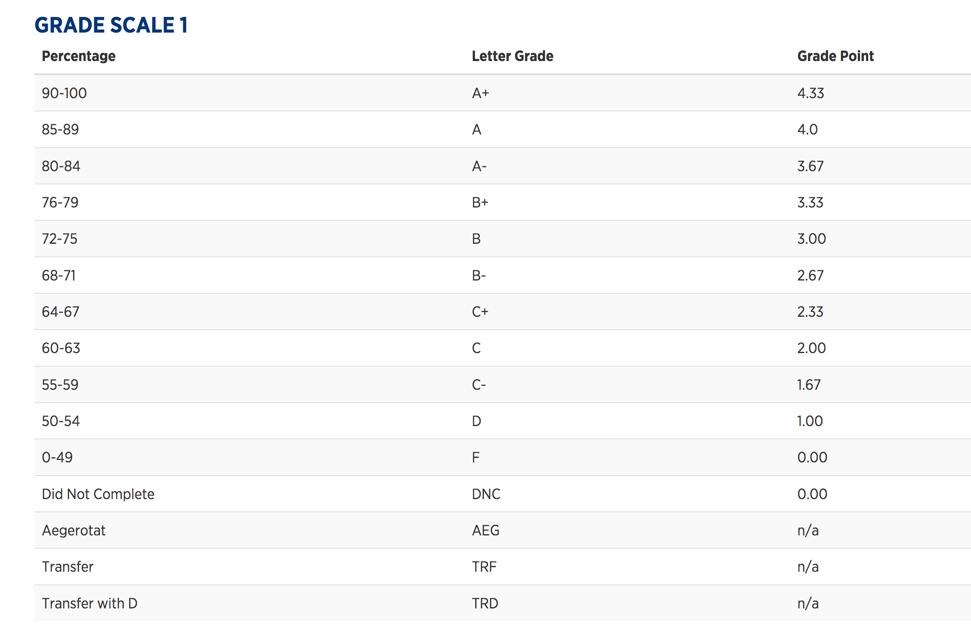

# 

# Student Services

Support Services for Students and Services for Students with Disabilities offer a variety of services to support learners of all backgrounds, ages, interests, and abilities. Here you’ll have access to:

* Resources for learning strategies (time management, note taking, etc);
* Book an appointment with a Counselor or Aboriginal Student Advisor;
* Arrange for assistance with a special need or disability; or get help with your course work.

Additional details and contact information regarding student services can be found on the NIC website:

<https://www.nic.bc.ca/student-services/>

[**College Policies:**](https://www.nic.bc.ca/about-us/the-nic-commitment/policies-procedures/)

Educational policies can be found on the NIC website:

[Community Code of Academic, Personal and Professional Conduct (3-06)](https://www.nic.bc.ca/pdf/policy-3-06-community-code-of-academic-pers-and-prof-conduct.pdf)

[Instructional Accommodation and Access Services for Students with Disabilities (3-17)](https://www.nic.bc.ca/pdf/policy-3-17-instructional-accommodation-and-accessible-learning-services.pdf)

[Student Appeals Policy (3-30)](https://www.nic.bc.ca/pdf/policy-3-30-student-appeal.pdf)

[Student Complaint Resolution Policy (3-31)](https://www.nic.bc.ca/pdf/policy-3-31-student-complaint-resolution.pdf)

[Evaluation of Student Performance Policy (3-33)](https://www.nic.bc.ca/pdf/policy-3-33-evaluation-of-student-performance.pdf)

[Sexualized Violence Prevention and Response Policy (3-34)](https://www.nic.bc.ca/pdf/policy-3-34-sexual-violence-and-misconduct.pdf)

[Course Outline Policy (3-35)](https://www.nic.bc.ca/pdf/policy-3-35-course-outline.pdf)

[Academic Standing and Progression (3-37)](https://www.nic.bc.ca/pdf/policy-3-37-academic-standing-and-progression.pdf)

[Grade System Policy (4-14)](https://www.nic.bc.ca/pdf/policy-4-14-grade-system.pdf)

ACADEMIC STANDARDS: ON-LINE MODULE

[*https://learn.nic.bc.ca/bbcswebdav/institution/Library%20Resources/empower/SupplementalScreens/modules.htm*](https://learn.nic.bc.ca/bbcswebdav/institution/Library%20Resources/empower/SupplementalScreens/modules.htm)



**ACADEMIC MISCONDUCT**

Plagiarism is a type of intellectual theft that involves "appropriating [copying] someone else's words or ideas without acknowledgment." *Source:* Plagiarism. (2001). In *Encyclopedia of Ethics*. Retrieved from<http://www.credoreference.com>.

Plagiarism can include, for example:

* forgetting to cite another's ideas, words or theories
* improper paraphrasing, quoting or summarizing (too close to the original source)
* copying word for word or copying images
* buying a paper online, or from a friend
* cutting and pasting from online sources
* claiming authorship of a paper you did not write
* colluding (i.e. working with an unattributed/unnamed person or persons) in the preparation and/or submission of an assignment

Plagiarism generally refers to using the work or words of another person, without the use of quotation marks and crediting the source. Additional examples of plagiarism include having someone else write a paper for you and downloading or buying a paper from the internet. In all cases, plagiarism is academic dishonesty. Avoiding plagiarism is easy: ***always paraphrase in your own words and give credit to the source.***

A student's academic conduct is very important, and North Island College takes plagiarism very seriously. Depending upon the seriousness of the offense, students may receive a score of zero or grade of 'F' for the assignment, or they may be suspended from the course, the program, or College.

For more information, see Policy 3-06 in the *North Island College Policies & Procedures Manual*.<https://www.nic.bc.ca/pdf/policy-3-06-community-code-of-academic-pers-and-prof-conduct.pdf>

The **Library & Learning Commons** provides useful information about citing and paraphrasing, and also offers instructional guides and online modules for all students, regardless of level and program. The College encourages all students to visit this site, to familiarize themselves with expectations around essay writing, and seek further guidance from their instructor(s) should any of the information, rules or policies pertaining to academic misconduct remain unclear.

The Library & Learning Commons, ‘Referencing, Citation and Plagiarism: Plagiarism Resources:<http://libguides.nic.bc.ca/c.php?g=19160&p=108017>

# 

**LEARNING STRATEGIES AND SUPPORTS**

There are many different NIC resources to help you during your studies. As an NIC student, all these services are available to you as part of our commitment to your success.

Educational Advising and Financial Aid is available through phone appointments on each campus and appointments can be booked online at [NIC Educational Advising Appointments](https://outlook.office365.com/owa/calendar/NICEnrollmentServicesAdvising@nic.bc.ca/bookings/)

# Counselling

To support you in your life and educational goals, our counsellors offer short-term counselling and coaching for personal challenges and unexpected circumstances, learning strategies and study skills, stress management, and conflict resolution. Counselling Services are available through telephone, email and video appointments and can be [booked online](https://outlook.office365.com/owa/calendar/NICCounsellingAppointments@nic.bc.ca/bookings/).

# Department of Accessible Learning Services (DALS)

Are you a student with a temporary or permanent disability? Our DALS faculty can help you to access resources and services to support and enhance your NIC experience.

# 

# Indigenous Student Supports

Elders in Residence are here to support Indigenous students. Contact information can be found at: [Elders in Residence | North Island College](https://www.nic.bc.ca/aboriginal-education/elders-in-residence/)

Indigenous advisors are available through phone appointments on each campus and appointments can be booked online at [NIC Educational Advising Appointments](https://outlook.office365.com/owa/calendar/NICEnrollmentServicesAdvising@nic.bc.ca/bookings/). Indigenous Advisors provide advice on matters related to:

* timetabling
* learning plans
* program changes
* emergency funding
* funding through Indigenous sponsorship organizations

Aboriginal Scholars is a holistic and culturally-relevant program for Indigenouskeiasb131313 students. The program strives to empower students through engaging them in the process of creating a self-constructed achievement plan, ensuring students have supports to enable them to complete their program, while also increasing the sense of community and Aboriginal awareness on campus.<https://www.nic.bc.ca/indigenous-education/aboriginal-scholars/>

# Student Employment Services

Available to support you with your employment needs via telephone/Skype. Book your appointment online, register for employment-related events, and access resources via [CareerCentral](https://careercentral.nic.bc.ca/home.htm)

# 

# Library and Learning Commons

See Library and Learning Commons services and hours at: [library.nic.bc.ca/home](https://library.nic.bc.ca/home). Other services include:

* **Library Research Support**

Our library team is here to help with assignment decoding, research strategies, navigating electronic resources and citation instruction.

* **Peer Tutoring**

Take advantage of NIC's peer tutoring services. Each student comes to the peer tutoring service with their own learning needs. We'll help you figure out your needs and develop a personalized tutoring plan <https://library.nic.bc.ca/PeerTutoring>.

* **Writing Support**

Are you struggling to write academic papers or meet the writing expectations for your coursework? We can help you! You can access writing support online through the Library and Learning Commons. Please see the following link for more information.<https://library.nic.bc.ca/WritingSupport>.

* **Math Support**

Are you struggling with some of the math concepts in your coursework? There is help available to you! Please see the following link for more information on how to book an appointment for math support.<https://library.nic.bc.ca/MathSupport>.

* **Computer Bookings/Study Spaces**

Computer and Study spaces are available at the Library & Learning Commons each morning from 8:00am - 12:00pm, and in computer labs on the CV and CR campuses from 12:00pm – 4:00pm. Click [HERE](https://library.nic.bc.ca/ComputerBookings) to book your spot. Printing is also available at these locations.

* **Student Technical Services**

Our Student Technical Service team is available to help you with any technical issues that you may be experiencing as a student. Please go to<https://library.nic.bc.ca/studenttech> for more information.

# International Student Support

# International student advising needs will be met through the international student advisors (ISA). You can [book a phone appointment or BlueJeans video conference](https://outlook.office365.com/owa/calendar/NICEnrollmentServicesAdvising@nic.bc.ca/bookings/) with an ISA. ISAs provide advice on matters related to:

* timetabling
* withdrawing
* learning plans
* program changes
* medical insurance overviews
* immigration advice (study permit extensions, co-op and post-grad work permits, visa inquiries, and off-campus work permits)

# 

# Learn Anywhere

# NIC's Learn Anywhere website is geared to provide a collection of information that will help you be successful learning digitally by covering areas such as: What is digital learning? How to be a digital learner while using NIC-supported technologies during your studies? A list of key skills and knowledge all students should have for successful learning in today's world, knowing your rights and responsibilities and [Technology Readiness Checklists](https://learnanywhere.opened.ca/digital-technologies/technology-readiness-checklists/). More details at:<https://learnanywhere.opened.ca/>

# Community Supports (24/7)

There are several supports available to help any student in distress. If you are in distress, please reach out for support.

* [**Vancouver Island Crisis Line:**](https://www.vicrisis.ca/)  24/7 1-888-494-3888 (Available to students located on Vancouver Island only)
* [**Crisis Suicide helpline**:](https://www.crisisservicescanada.ca/en/)  24/7 1-800-784-2433 (Available to students located in Canada only)]
* [**BC 211**:](https://www.bc211.ca/)  Full list of community services available across BC. Dial 2-1-1 on BC cellphone (Available to students located in BC only).
* [**Here2Talk**:](https://here2talk.ca/home)  24/7 counselling support for post-secondary students: 1-877-857-3397 (Available to students located in Canada and offshore)